

**INFORMATION TECHNOLOGY INSTITUTE**

**ITI Power bi developer track**

Examination System

Feb 2024



**Made by: -**

* Shimaa Abdelaal
* Rahma Tarek
* Esraa Emad
* Marwa Samir
* **Introduction:**

The project’s purpose is to design automated system that can perform online exams.

* **Database design:**

**Entities identifications: -**

1. **Students:**

Represents data about students, like **st_id, st_fname, st_lname, st_age, st_address, st_email.**

1. **Departments:**

Represents data about departments, like **dept_id, dept_name, dept_location, mgr_hiredate.**

1. **Instructors:**

Represents data about instructors, like **ins_id, ins_name, salary.**

1. **Courses:**

Represents data about courses, like **crs_id, crs_name, crs_duration.**

1. **Topics:**

Represents data about topics, like **top_id, top_name.**

1. **Skills:**

Represents data about skills, like **sk_id, sk_name.**

1. **Projects:**

Represents data about projects, like **pro_id, pro_name, start_date, end_date.**

1. **Company:**

Represents data about company, like **company_id, company_name, location.**

1. **Position:**

Represents data about positions, like **position_id, position_name, salary.**

1. **Training:**

Represents data about training, like **training_id, training_name, start_date, end_date.**

1. **Freelancing:**

Represents data about freelancing, like **freelancing_id, freelancing_name.**

1. **Certificates:**

Represents data about certificates, like **cre_id, cre_name, issuer, issue_date.**

1. **Exams:**

Represents data about exams, like **exam_id, exam_name, exam_date.**

1. **Exam_questions:**

Represents data about exam_questions, like **question_id, question_text, question_type.**

1. **Question_option:**

Represents data about question_options, like **option_id, option_text, is_currect.**

1. **Exam_answers:**

Represents data about exam_answers, like **answer_id, answer_text, score.**

**ERD_diagram: -**

This diagram explains the relationships, the cardinality ratio and participations between entities.

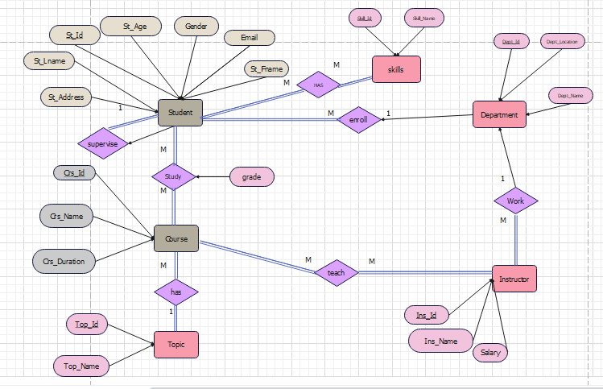

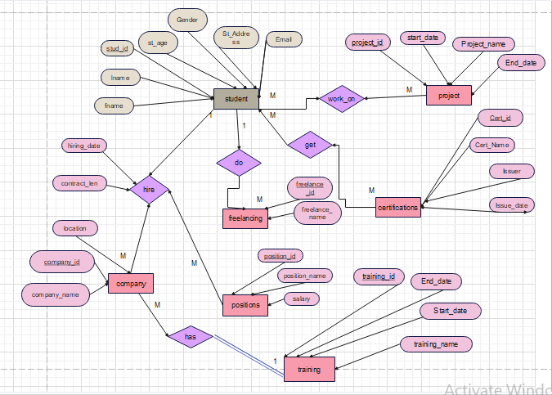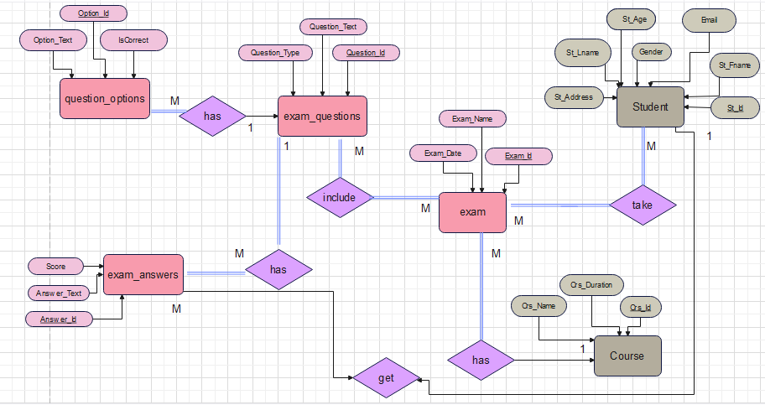

1. Each student must enroll in one department and each department may have many students.
2. Each instructor must work in many departments and each department may have many instructors.
3. Each student must study many courses and each course must being studied by many students with grade.
4. Each instructor must teach many courses and each course must being taught with many instructors.
5. Each course must have 1 topic but each topic must have many courses.
6. Each student must be under supervised by 1 supervisor but supervisor may supervise many students.
7. Each student must have many skills and each skill must be in many students.
8. Each student works on many projects and each project must have many students.
9. Each student may get many certificates and each certificate may be owned with many students.
10. Each student may do many freelancing jobs and each freelancing job may be done by many students.
11. Each company hiring with many positions with hiring date and contract length and many students may apply.
12. Each company may have 1 training program for every position and each training program must be in many companies.
13. Each student must take many exams and each exam must be taken with many students.
14. Each exam must be for 1 course and each course may have many exams.
15. Each exam must have many questions and each question must be in many exams.
16. Each exam may have many options and each option must be in 1 question.
17. Each question must have many answers and each answer must have 1 question.
18. Each student may have many answers but each answer to 1 student.

**Mapping: -**

convert the conceptual design to logical design, and represent the relationships.

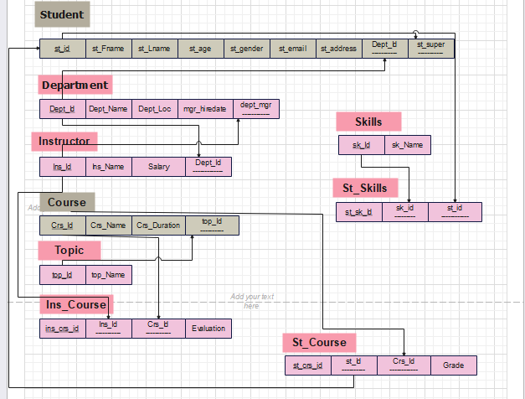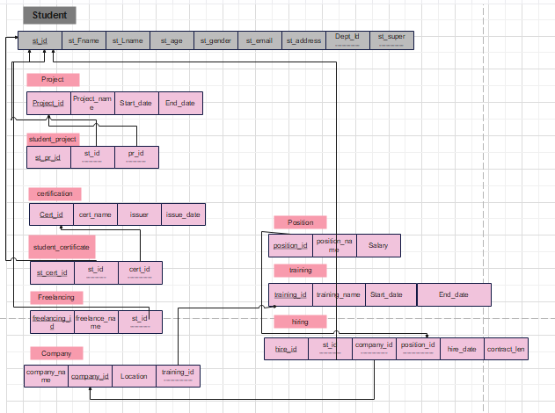

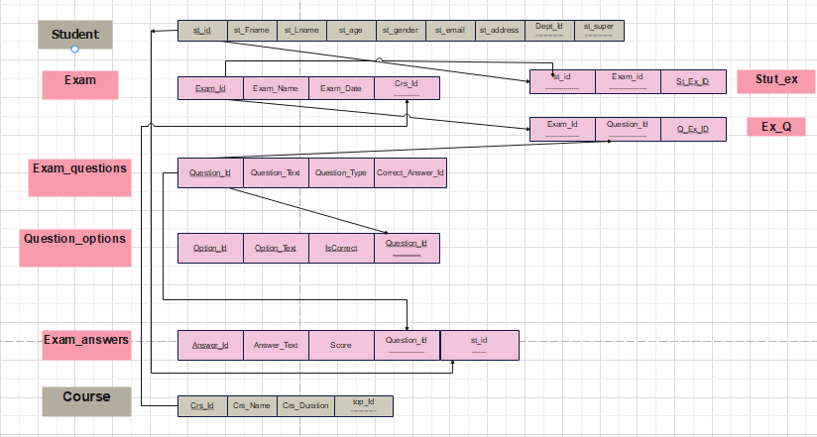

**Physical Model:**

The creation of the tables using SQL queries.

1. **Student:**

CREATE TABLE [dbo].[Student](

[St_Id] int IDENTITY(1,1) NOT NULL,

[St_Fname] varchar(100),

[St_Lname] varchar(100),

[St_Address] varchar(100),

[St_Age] int,

[Email] varchar(100),

[Dept_Id] int,

[St_super] int,

[Gender] varchar(50),

CONSTRAINT [FK_Student_Department] FOREIGN KEY([Dept_Id]) REFERENCES [dbo].[Department] ([Dept_Id]),

CONSTRAINT [FK_Student_Student] FOREIGN KEY([St_super]) REFERENCES [dbo].[Student] ([St_Id]))

1. **Department:**

CREATE TABLE [dbo].[Department](

[Dept_Id] int IDENTITY(1,1) NOT NULL,

[Dept_Name] varchar(100),

[Dept_Location] varchar(100),

[Dept_Manager] int,

[Manager_hiredate] date,

CONSTRAINT [FK_Department_Instructor] FOREIGN KEY([Dept_Manager]) REFERENCES [dbo].[Instructor] ([Ins_Id]))

1. **Instructor:**

CREATE TABLE [dbo].[Instructor](

[Ins_Id] int IDENTITY(1,1) NOT NULL,

[Ins_Name] varchar(100),

[Salary] int,

[Dept_Id] int,

CONSTRAINT [FK_Instructor_Department] FOREIGN KEY([Dept_Id]) REFERENCES [dbo].[Department] ([Dept_Id]))

1. **Course:**

CREATE TABLE [dbo].[Course](

[Crs_Id] int IDENTITY(1,1) NOT NULL,

[Crs_Name] varchar(100),

[Crs_Duration] int,

[Top_Id] int,

CONSTRAINT [FK_Course_Topic] FOREIGN KEY([Top_Id]) REFERENCES [dbo].[Topic] ([Top_Id]))

1. **Topic:**

CREATE TABLE [dbo].[Topic](

[Top_Id] int IDENTITY(1,1) NOT NULL,

[Top_Name] varchar(100))

1. **Skills:**

CREATE TABLE [dbo].[Skills](

[Skill_Id] int IDENTITY(1,1) NOT NULL,

[Skill_Name] varchar(100))

1. **Student_skills:**

CREATE TABLE [dbo].[Student_skills](

[Sk_St_id] int IDENTITY(1,1) NOT NULL,

[Sk_Id] int,

[St_Id] int,

CONSTRAINT [FK_Student_skills_Skills] FOREIGN KEY([Sk_Id]) REFERENCES [dbo].[Skills] ([Skill_Id]),

CONSTRAINT [FK_Student_skills_Student] FOREIGN KEY([St_Id]) REFERENCES [dbo].[Student] ([St_Id]))

1. **Student_course:**

CREATE TABLE [dbo].[Student_course](

[Crs_Id] int,

[St_Id] int,

[Grade] int,

[crs_st_id] int IDENTITY(1,1) NOT NULL,

CONSTRAINT [FK_Student_course_Course] FOREIGN KEY([Crs_Id]) REFERENCES [dbo].[Course] ([Crs_Id]),

CONSTRAINT [FK_Student_course_Student] FOREIGN KEY([St_Id]) REFERENCES [dbo].[Student] ([St_Id]))

1. **Instructor_course:**

CREATE TABLE [dbo].[Instructor_course](

[Ins_Crs_ID] int IDENTITY(1,1) NOT NULL,

[Ins_Id] int,

[Crs_Id] int,

[Evaluation] varchar(100) NULL,

CONSTRAINT [FK_Instructor_course_Instructor] FOREIGN KEY([Ins_Id]) REFERENCES [dbo].[Instructor] ([Ins_Id]),

CONSTRAINT [FK_Instructor_course_Course] FOREIGN KEY([Crs_Id]) REFERENCES [dbo].[Course] ([Crs_Id]))

1. **Certificates:**

CREATE TABLE [dbo].[Certificates](

[Cert_Id] int IDENTITY(1,1) NOT NULL,

[Cert_Name] varchar(100),

[Issuer] varchar(100),

[Issue_Date] date)

1. **Student_Certificates:**

CREATE TABLE [dbo].[Student_Certificates](

[St_Cer_ID] int IDENTITY(1,1) NOT NULL,

[St_Id] int,

[Cert_Id] int,

CONSTRAINT [FK_Student_Certificates_Student] FOREIGN KEY([St_Id]) REFERENCES [dbo].[Student] ([St_Id]),

CONSTRAINT [FK_Student_Certificates_Certificates] FOREIGN KEY([Cert_Id]) REFERENCES [dbo].[Certificates] ([Cert_Id]))

1. **Freelancing:**

CREATE TABLE [dbo].[Freelancing](

[Freelance_Id] int IDENTITY(1,1) NOT NULL,

[Freelance_Name] varchar(100) NULL,

[St_Id] int NULL,

CONSTRAINT [FK_Freelancing_Student] FOREIGN KEY([St_Id]) REFERENCES [dbo].[Student] ([St_Id]))

1. **Companies:**

CREATE TABLE [dbo].[Companies](

[Company_Id] int IDENTITY(1,1) NOT NULL,

[Company_Name] varchar(100),

[Location] varchar(100),

[Training_ID] int,

CONSTRAINT [FK_Companies_Training] FOREIGN KEY([Training_ID]) REFERENCES [dbo].[Training] ([Train_ID]))

1. **Positions:**

CREATE TABLE [dbo].[Positions](

[Position_Id] int IDENTITY(1,1) NOT NULL,

[Position_Name] varchar(100),

[Salary] int)

1. **Hiring:**

CREATE TABLE [dbo].[Hiring](

[Hiring_Id] int IDENTITY(1,1) NOT NULL,

[Company_Id] int,

[Position_Id] int,

[St_Id] int,

[Hire_Date] date,

[ContractLength] int,

CONSTRAINT [FK_Hiring_Companies] FOREIGN KEY([Company_Id]) REFERENCES [dbo].[Companies] ([Company_Id]),

CONSTRAINT [FK_Hiring_Positions] FOREIGN KEY([Position_Id]) REFERENCES [dbo].[Positions] ([Position_Id]),

CONSTRAINT [FK_Hiring_Student] FOREIGN KEY([St_Id]) REFERENCES [dbo].[Student] ([St_Id]))

1. **Training:**

CREATE TABLE [dbo].[Training](

[Train_ID] int IDENTITY(1,1) NOT NULL,

[Train_Name] varchar(100),

[Start_Date] date,

[End_Date] date)

1. **Projects:**

CREATE TABLE [dbo].[Projects](

[Project_Id] int IDENTITY(1,1) NOT NULL,

[Project_Name] varchar(100),

[Start_Date] date,

[End_Date] date)

1. **Student_Project:**

CREATE TABLE [dbo].[Student_Project](

[St_Pro_Id] int IDENTITY(1,1) NOT NULL,

[St_Id] int,

[Pro_Id] int,

CONSTRAINT [FK_Student_Project_Project] FOREIGN KEY([Pro_Id]) REFERENCES [dbo].[Projects] ([Project_Id]),

CONSTRAINT [FK_Student_Project_Student] FOREIGN KEY([St_Id]) REFERENCES [dbo].[Student] ([St_Id]))

1. **Exam:**

CREATE TABLE [dbo].[Exam](

[Exam_Id] int IDENTITY(1,1) NOT NULL,

[Exam_Name] varchar](100),

[Exam_Date] date,

[Crs_Id] int,

CONSTRAINT [FK_Exam_Course] FOREIGN KEY(Crs_Id]) REFERENCES [dbo].[Course] ([Crs_Id]))

1. **St_Exam:**

CREATE TABLE [dbo].[St_Exam](

[St_Ex_Id] int IDENTITY(1,1) NOT NULL,

[St_Id] int,

[Ex_Id] int,

CONSTRAINT [FK_Student_Exam_Student] FOREIGN KEY([St_Id]) REFERENCES [dbo].[Student] ([St_Id]),

CONSTRAINT [FK_Student_Exam_Exam] FOREIGN KEY([Ex_Id]) REFERENCES [dbo].[Exam] ([Exam_Id]))

1. **Exam_answers:**

CREATE TABLE [dbo].[Exam_answers](

[Answer_Id] int IDENTITY(1,1) NOT NULL,

[Answer_Text] varchar(300),

[Question_Id] int,

[Score] int,

[St_Id] int,

CONSTRAINT [FK_Exam_answers_Exam_questions] FOREIGN KEY([Question_Id]) REFERENCES [dbo].[Exam_questions] ([Question_Id]),

CONSTRAINT [FK_Exam_answers_Student] FOREIGN KEY([St_Id]) REFERENCES [dbo].[Student] ([St_Id]))

1. **Exam_questions:**

CREATE TABLE [dbo].[Exam_questions](

[Question_Id] int IDENTITY(1,1) NOT NULL,

[Question_Text] varchar(200),

[Question_Type] varchar(50),

[Correct_Answer_Id] int,

[Category_Name] varchar(100),

CONSTRAINT [FK_Exam_questions_Exam_answers] FOREIGN KEY([Correct_Answer_Id]) REFERENCES [dbo].[Exam_answers] ([Answer_Id]))

1. **Ques_Exam:**

CREATE TABLE [dbo].[Ques_Exam](

[Q_Ex_Id] int IDENTITY(1,1) NOT NULL,

[Ex_Id] int,

[Q_Id] int,

CONSTRAINT [FK_Ques_Exam_Exam] FOREIGN KEY([Ex_Id]) REFERENCES [dbo].[Exam] ([Exam_Id]),

CONSTRAINT [FK_Ques_Exam_Exam_questions] FOREIGN KEY([Q_Id]) REFERENCES [dbo].[Exam_questions] ([Question_Id]))

1. **Ques_Exam:**

CREATE TABLE [dbo].[Question_options](

[Option_Id] int IDENTITY(1,1) NOT NULL,

[Option_Text] varchar(max),

[IsCorrect] int,

[Question_Id] int,

[Category_Name] varchar(100),

CONSTRAINT [FK_Question_options_Exam_questions] FOREIGN KEY([Question_Id]) REFERENCES [dbo].[Exam_questions] ([Question_Id]))

**Reports using SSRS:**

1. Report that returns the students information according to Department No parameter.

CREATE PROCEDURE StudentInfo

@DeptId INT

AS

BEGIN

SET NOCOUNT ON;

SELECT S.St_Id, S.St_Fname, S.St_Lname, S.St_Address, S.St_Age, S.Email, S.Gender

FROM Student S

INNER JOIN Department D ON S.Dept_Id = D.Dept_Id

WHERE D.Dept_Id = @DeptId;

END;

StudentInfo @DeptId = 102

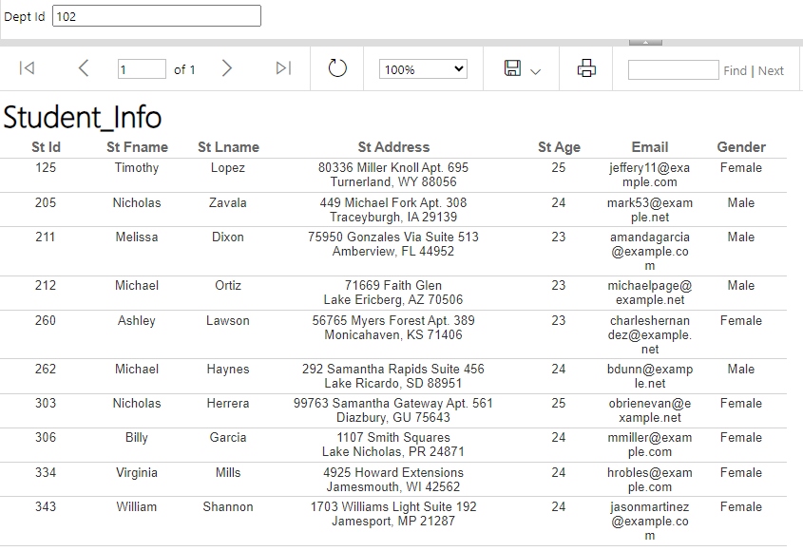

1. Report that takes the student ID and returns the grades of the student in all courses.

CREATE PROCEDURE GetStudentGrades

@StudentID INT

AS

BEGIN

SET NOCOUNT ON;

SELECT

C.Crs_Name AS CourseName,

SC.Grade

FROM

Student_course SC

INNER JOIN

Course C ON SC.Crs_Id = C.Crs_Id

WHERE

SC.St_Id = @StudentID;

END;

EXEC GetStudentGrades @StudentID = 271;

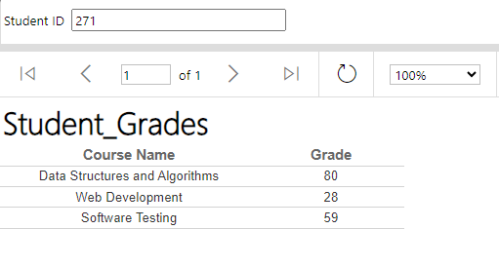

1. Report that takes the instructor ID and returns the name of the courses that he teaches and the number of students per course.

CREATE PROCEDURE GetrCoursesAndStudentsNum

@InstructorID INT

AS

BEGIN

SET NOCOUNT ON;

SELECT

C.Crs_Name AS CourseName,

COUNT(SC.St_Id) AS NumberOfStudents

FROM

Instructor_course IC

INNER JOIN

Course C ON IC.Crs_Id = C.Crs_Id

LEFT JOIN

Student_course SC ON IC.Crs_Id = SC.Crs_Id

WHERE

IC.Ins_Id = @InstructorID

GROUP BY

C.Crs_Name;

END;

GetrCoursesAndStudentsNum @InstructorID=22

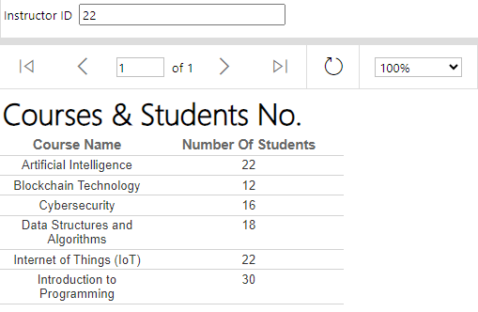

1. Report that takes course ID and returns its topics

CREATE PROCEDURE GetCourseTopics

@CourseID INT

AS

BEGIN

SET NOCOUNT ON;

SELECT

T.Top_Name AS TopicName

FROM

Course C

INNER JOIN

Topic T ON C.Top_Id = T.Top_Id

WHERE

C.Crs_Id = @CourseID;

END;

EXEC GetCourseTopics @CourseID = 90;

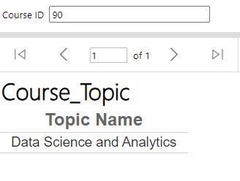

1. Report that takes exam number and returns the Questions in it and chocies [freeform report]

create PROCEDURE GetExamQuestionsAndChoices

@ExamNumber INT

AS

BEGIN

SET NOCOUNT ON;

WITH CTE AS (

SELECT

CASE

WHEN ROW_NUMBER() OVER (PARTITION BY EQ.Question_Text ORDER BY (SELECT NULL)) = 1 THEN EQ.Question_Text

ELSE ''

END AS Question_Text,

QO.Option_Text,

QO.IsCorrect

FROM

Exam E

INNER JOIN

Ques_Exam QE ON E.Exam_Id = QE.Ex_Id

INNER JOIN

Exam_questions EQ ON QE.Q_Id = EQ.Question_Id

LEFT JOIN

Question_options QO ON EQ.Question_Id = QO.Question_Id

WHERE

E.Exam_Id = @ExamNumber

)

SELECT

Question_Text,

Option_Text,

IsCorrect

FROM CTE;

END;

EXEC GetExamQuestionsAndChoices @ExamNumber =383;

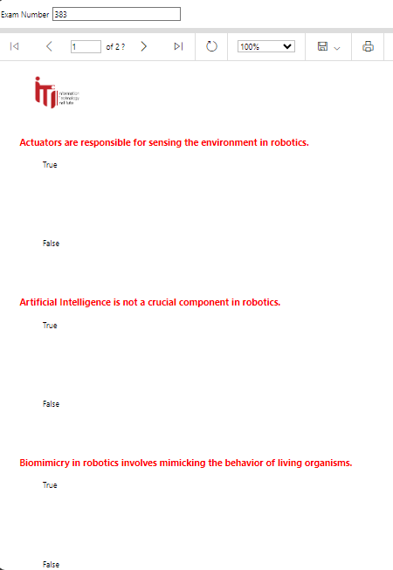

1. Report that takes exam number and the student ID then returns the Questions in this exam with the student answers.

CREATE PROCEDURE GetExamQuestionsAndAnswers

@ExamId INT,

@StudentId INT

AS

BEGIN

SET NOCOUNT ON;

SELECT EQ.Question_Text,

EA.Answer_Text AS Student_Answer,

EA.Score

FROM Exam E

INNER JOIN Ques_Exam QE ON E.Exam_Id = QE.Ex_Id

INNER JOIN Exam_questions EQ ON QE.Q_Id = EQ.Question_Id

LEFT JOIN Exam_answers EA ON EQ.Question_Id = EA.Question_Id

LEFT JOIN Student S ON EA.St_Id = S.St_Id

LEFT JOIN St_Exam SE ON E.Exam_Id = SE.Ex_Id AND S.St_Id = SE.St_Id

WHERE E.Exam_Id = @ExamId

AND S.St_Id = @StudentId;

END;

EXEC GetExamQuestionsAndAnswers @ExamId = 373, @StudentId = 106;

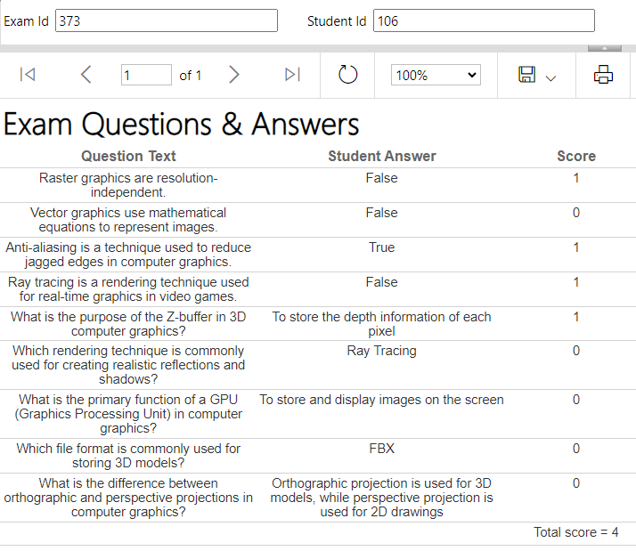

**Data warehousing:**

Creation of dimension and fact tables.

1. **Dim_Exam:**

This table holds information about exams. It includes details such as exam ID (both surrogate and business key), exam name, date, and related question and answer details.

CREATE TABLE [dbo].[Dim_Exam](

[exam_id_sk] int IDENTITY(1,1) NOT NULL,

[exam_id_bk] int,

[exam_name] varchar(100),

[exam_date] date,

[question_id_bk] int,

[question_text] varchar(200),

[question_type] varchar(50),

[correct_answer_id] int,

[answer_id_bk] int,

[answer_text] varchar(300),

[score] int,

[option_id_bk] int,

[option_text] varchar(300),

[is_correct] int,

[start_date] datetime,

[end_date] datetime,

[is_current] tinyint,

CONSTRAINT [FK_Dim_Exam_Fact_table] FOREIGN KEY([exam_id_sk]) REFERENCES [dbo].[Fact_table] ([exam_id_fk]))

1. **Dim_Hiring:**

This table stores data related to hiring processes. It includes hiring ID (surrogate and business key), hire date, contract length, company details, training information, position details, salary, and temporal information.

CREATE TABLE [dbo].[Dim_Hiring](

[hiring_id_sk] int IDENTITY(1,1) NOT NULL,

[hiring_id_bk] int,

[hire_date] date,

[contract_length] int,

[company_id_bk] int,

[company_name] varchar(100),

[location] varchar(100),

[training_id_bk] int,

[training_name] varchar(100),

[training_startdate] date,

[training_enddate] date,

[position_id_bk] int,

[position_name] varchar(100),

[salary] int,

[start_date] datetime,

[end_date] datetime,

[is_current] tinyint,

CONSTRAINT [FK_Dim_Hiring_Fact_table] FOREIGN KEY ([hiring_id_sk]) REFERENCES [dbo].[Fact_table] ([hiring_id_fk]))

1. **Dim_Student:**

This table contains information about students. It includes student ID (surrogate and business key), name, address, age, email, department details, certification information, freelancing details, skill and project information, temporal data, etc.

CREATE TABLE [dbo].[Dim_Student](

[st_id_sk] int IDENTITY(1,1) NOT NULL,

[st_id_bk] int,

[st_fname] varchar(100),

[st_lname] varchar(100),

[st_address] varchar(100),

[st_age] int,

[email] varchar(100),

[st_super_bk] int,

[gender] varchar(50),

[dept_id_bk] int,

[dept_name] varchar(100),

[dept_location] varchar(100),

[dept_mgr] int,

[mgr_hiredate] date,

[cert_id_bk] int,

[cert_name] varchar(100),

[issuer] varchar(100),

[issue_date] date,

[freelancing_id_bk] int,

[freelancing_name] varchar(100),

[skill_id] int,

[skill_name] varchar(100),

[project_id] int,

[project_name] varchar(100),

[pro_startdate] date,

[pro_enddate] date,

[start_date] datetime,

[end_date] datetime,

[is_current] tinyint,

CONSTRAINT [FK_Dim_Student_Fact_table] FOREIGN KEY ([st_id_sk]) REFERENCES [dbo].[Fact_table] ([student_id_fk]))

1. **DimDate:**

This table is a time dimension table. It includes various attributes related to dates such as day, month, quarter, year, and some additional attributes like holiday text.

CREATE TABLE [dbo].[DimDate](

[DateSK] int NOT NULL,

[Date] date NOT NULL,

[Day] char(2) NOT NULL,

[DaySuffix] varchar(4) NOT NULL,

[DayOfWeek] varchar(9) NOT NULL,

[DOWInMonth] tinyint NOT NULL,

[DayOfYear] int NOT NULL,

[WeekOfYear] tinyint NOT NULL,

[WeekOfMonth] tinyint NOT NULL,

[Month] char(2) NOT NULL,

[MonthName] varchar(9) NOT NULL,

[Quarter] tinyint NOT NULL,

[QuarterName] varchar(6) NOT NULL,

[Year] char(4) NOT NULL,

[StandardDate] varchar(10) NULL,

[HolidayText] varchar(50) NULL,

CONSTRAINT [FK_DimDate_Fact_table] FOREIGN KEY ([DateSK]) REFERENCES [dbo].[Fact_table] ([date_id_fk]))

1. **Fact_table:**

This table represents a fact table that likely holds the central metrics or measurements of interest. It includes foreign keys to the dimension tables (Dim_Exam, Dim_Hiring, Dim_Student, DimDate) and additional attributes like course details, instructor details, salary, grade, and creation timestamp.

CREATE TABLE [dbo].[Fact_table](

[fact_id_sk] int IDENTITY(1,1) NOT NULL,

[hiring_id_fk] int,

[exam_id_fk] int,

[student_id_fk] int,

[date_id_fk] int,

[crs_id_bk] int,

[crs_name] varchar(100),

[crs_duration] int,

[topic_id_bk] int,

[topic_name] varchar(100),

[ins_id_bk] int,

[ins_name] varchar(100),

[salary] int,

[grade] int,

[created_at] datetime,

CONSTRAINT [FK_Fact_table_Dim_Exam] FOREIGN KEY ([exam_id_fk]) REFERENCES [dbo].[Dim_Exam] ([exam_id_sk]),

CONSTRAINT [FK_Fact_table_Dim_Hiring] FOREIGN KEY ([hiring_id_fk]) REFERENCES [dbo].[Dim_Hiring] ([hiring_id_sk]),

CONSTRAINT [FK_Fact_table_Dim_Student] FOREIGN KEY ([student_id_fk]) REFERENCES [dbo].[Dim_Student] ([st_id_sk]),

CONSTRAINT [FK_Fact_table_DimDate] FOREIGN KEY ([date_id_fk]) REFERENCES [dbo].[DimDate] ([DateSK]))

**DWH_Diagram:**

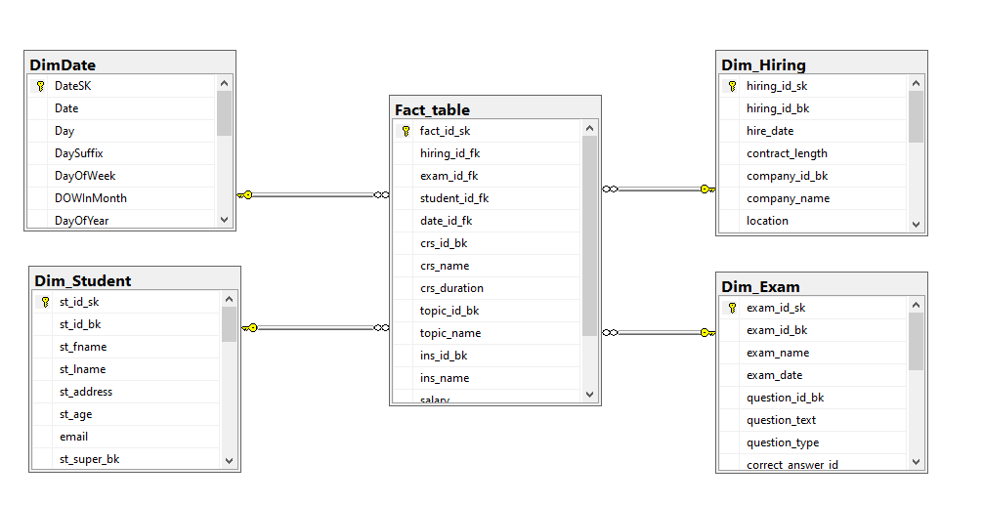

**ETL using SSIS:**

1. **Dim_Exam:**

select e.Exam_Id, e.Exam_Name, e.Exam_Date, eq.Question_Id, eq.Question_Text, eq.Question_Type, eq.Correct_Answer_Id,

qo.Option_Id, qo.Option_Text, qo.IsCorrect, ea.Answer_Id, ea.Answer_Text, ea.Score

from exam e left join Ques_Exam qe

on e.Exam_Id = qe.Ex_Id

left join Exam_questions eq

on qe.Q_Id = eq.Question_Id

left join Question_options qo

on qo.Question_Id = eq.Question_Id

left join Exam_answers ea

on ea.Question_Id = eq.Question_Id

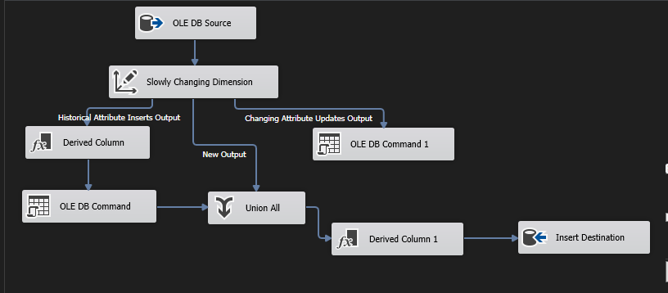

1. **Dim_Hiring:**

select c.Company_Id, c.Company_Name, c.Location, t.Train_ID, t.Train_Name, t.Start_Date,

t.End_Date, h.Hiring_Id, h.Hire_Date, h.ContractLength, p.Position_Id, p.Position_Name, p.Salary

from Companies c left join Training t

on t.Train_ID = c.Training_ID

left join Hiring h

on h.Company_Id = c.Company_Id

left join Positions p

on p.Position_Id = h.Position_Id

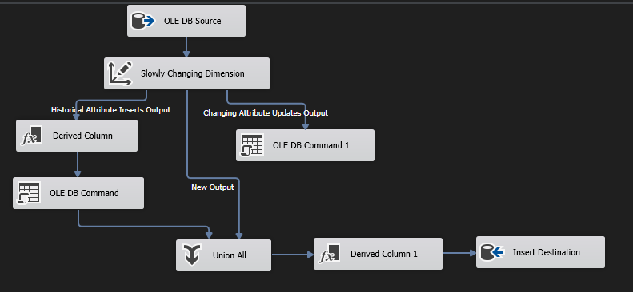

1. **Dim_Student:**

select s.St_Id, s.St_Fname, s.St_Lname, s.St_Address, s.Gender, s.St_Age,s.Email, s.St_super, c.Cert_Id, c.Cert_Name, c.Issue_Date, c.Issuer,

d.Dept_Id, d.Dept_Name, d.Dept_Location, d.Dept_Manager, d.Manager_hiredate, sk.Skill_Id, sk.Skill_Name, f.Freelance_Id, f.Freelance_Name,

p.Project_Id, p.Project_Name, p.Start_Date, p.End_Date

from student s left join Student_Certificates sc

on s.St_Id = sc.St_Id

left join Certificates c

on c.Cert_Id = sc.Cert_Id

left join Department d

on d.Dept_Id = s.Dept_Id

left join Student_skills ss

on ss.St_Id = s.St_Id

left join Skills sk

on sk.Skill_Id = ss.Sk_Id

left join Freelancing f

on f.St_Id = s.St_Id

left join Student_Project sp

on sp.St_Id = s.St_Id

left join Projects p

on sp.Pro_Id = p.Project_Id

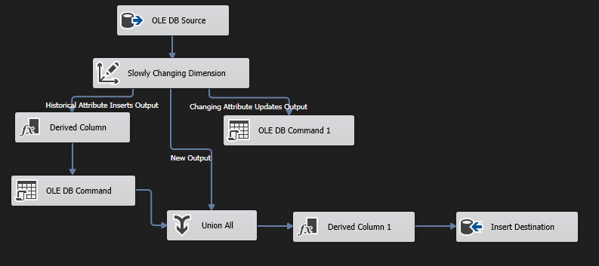

1. **Fact_table:**

select s.St_Id, h.Hiring_Id, e.Exam_Id, c.Crs_Id, c.Crs_Name, c.Crs_Duration, c.Top_Id, t.Top_Name, i.Ins_Id,

i.Ins_Name, i.Salary, sc.Grade, d.Manager_hiredate, ce.Issue_Date, e.Exam_Date, h.Hire_Date

from Student s inner join Student_course sc

on s.St_Id = sc.St_Id

inner join Course c

on c.Crs_Id = sc.Crs_Id

inner join Instructor_course ic

on ic.Crs_Id = c.Crs_Id

inner join Instructor i

on i.Ins_Id = ic.Ins_Id

inner join Topic t

on t.Top_Id = c.Top_Id

inner join Department d

on s.Dept_Id = d.Dept_Id

inner join Hiring h

on h.St_Id = s.St_Id

inner join Exam e

on e.Crs_Id = c.Crs_Id

inner join Student_Certificates ss

on ss.St_Id = s.St_Id

inner join Certificates ce

on ce.Cert_Id = ss.Cert_Id

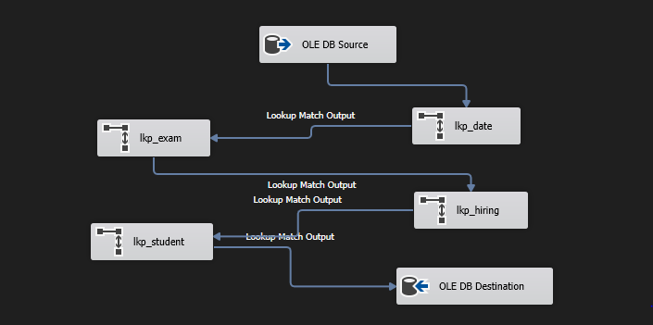

**Select stored procedures:**

1. **Certificates_table:**

create proc GetCertificateData as

select * from Certificates

1. **Companies_table:**

create proc GetCompaniesData as

select * from Companies

1. **Course_table:**

create proc GetcourseData as

select * from Course

1. **Department_table:**

create proc GetDepartmentData as

select * from Department

1. **Exam_table:**

create proc GetExamData as

select * from Exam

1. **Exam_answers_table:**

create proc GetExamAswersData as

select * from Exam_answers

1. **Exam_questions_table:**

create proc GetExamQuestionData as

select * from Exam_questions

1. **Freelancing_table:**

create proc GetFreelacingData as

select * from Freelancing

1. **Hiring _table:**

create proc GetExamHringData as

select * from Hiring

1. **Instructor_table:**

create proc GetInstructorData as

select * from Instructor

1. **Instructor_course_table:**

create proc GetInstructorCourseData as

select * from Instructor_course

1. **Positions_table:**

create proc GetPositionData as

select * from Positions

1. **Projects_table:**

create proc GetProjectsData as

select * from Projects

1. **Ques_Exam_table:**

create proc GetQues_ExamData as

select * from Ques_Exam

1. **Question_options_table:**

create proc GetQuestion_optionsData as

select * from Question_options

1. **Skills_table:**

create proc GetSkillsData as

select * from Skills

1. **St_Exam_table:**

create proc GetStExamData as

select * from St_Exam

1. **Student_table:**

create proc GetStudentData as

select * from Student

1. **Student_Certificates_table:**

create proc GetStudentCertificatesData as

select * from Student_Certificates

1. **Student_course_table:**

create proc GetStudentCourseData as

select * from Student_course

1. **Student_Project_table:**

create proc GetStudenProjectstData as

select * from Student_Project

1. **Student_skills_table:**

create proc GetStudentSkillsData as

select * from Student_skills

1. **Topic_table:**

create proc GetTopicData as

select * from Topic

1. **Training_table:**

create proc GettraningData as

select * from Training

**Insert stored procedures:**

1. **Certificates_table:**

CREATE PROCEDURE InsertCertificate

@Cert_Name VARCHAR(100),

@Issuer VARCHAR(100),

@Issue_Date DATE

AS

BEGIN

SET NOCOUNT ON;

INSERT INTO [dbo].[Certificates] ([Cert_Name], [Issuer], [Issue_Date])

VALUES (@Cert_Name, @Issuer, @Issue_Date);

SELECT SCOPE_IDENTITY() AS Cert_Id;

END;

1. **Companies_table:**

create PROCEDURE InsertCompany

@Company_Name VARCHAR(100),

@Location VARCHAR(100),

@Training_ID INT

AS

BEGIN

SET NOCOUNT ON;

INSERT INTO [dbo].[Companies] ([Company_Name], [Location],[Training_ID])

VALUES (@Company_Name, @Location, @Training_ID);

END;

1. **Course_table:**

create PROCEDURE InsertCourse

@Crs_Name VARCHAR(100),

@Crs_Duration INT,

@Top_Id INT

AS

BEGIN

SET NOCOUNT ON;

INSERT INTO [dbo].[Course] ([Crs_Name], [Crs_Duration], [Top_Id])

VALUES (@Crs_Name, @Crs_Duration, @Top_Id);

END;

1. **Department_table:**

CREATE PROCEDURE InsertDepartment

@Dept_Name VARCHAR(100),

@Dept_Location VARCHAR(100),

@Dept_Manager INT,

@Manager_hiredate DATE

AS

BEGIN

SET NOCOUNT ON;

INSERT INTO [dbo].[Department] ([Dept_Name], [Dept_Location], [Dept_Manager], [Manager_hiredate])

VALUES (@Dept_Name, @Dept_Location, @Dept_Manager, @Manager_hiredate);

END;

1. **Exam_table:**

CREATE PROCEDURE InsertExam

@Exam_Name VARCHAR(100),

@Exam_Date DATE,

@Crs_Id INT

AS

BEGIN

SET NOCOUNT ON;

INSERT INTO [dbo].[Exam] ([Exam_Name], [Exam_Date], [Crs_Id])

VALUES (@Exam_Name, @Exam_Date, @Crs_Id);

END;

1. **Exam_answers_table:**

Create PROCEDURE InsertExamAnswer

@Answer_Text VARCHAR(100),

@Question_Id INT,

@Score INT,

@st_id INT

AS

BEGIN

SET NOCOUNT ON;

INSERT INTO [dbo].[Exam_answers] ([Answer_Text],[Question_Id] ,[Score],[St_Id])

VALUES (@Answer_Text,@Question_Id, @Score, @st_id );

END;

1. **Exam_questions_table:**

CREATE PROCEDURE InsertExamQuestion

@Question_Text VARCHAR(100),

@Question_Type VARCHAR(50),

@Correct_ans int,

@Category varchar(100)

AS

BEGIN

SET NOCOUNT ON;

INSERT INTO [dbo].[Exam_questions] ( [Question_Text], [Question_Type],[Correct_Answer_Id],[Category_Name])

VALUES ( @Question_Text, @Question_Type,@Correct_ans ,@Category);

END;

1. **Freelancing_table:**

CREATE PROCEDURE InsertFreelancing

@Freelance_Name VARCHAR(100),

@St_Id INT

AS

BEGIN

SET NOCOUNT ON;

INSERT INTO [dbo].[Freelancing] ([Freelance_Name],[St_Id])

VALUES (@Freelance_Name,@St_Id);

END;

1. **Hiring _table:**

CREATE PROCEDURE InsertHiring

@Company_Id INT,

@Position_Id INT,

@St_Id INT,

@Hire_Date DATE,

@ContractLength INT

AS

BEGIN

SET NOCOUNT ON;

INSERT INTO [dbo].[Hiring] ([Company_Id], [Position_Id], [St_Id], [Hire_Date], [ContractLength])

VALUES (@Company_Id, @Position_Id, @St_Id, @Hire_Date, @ContractLength);

END;

1. **Instructor_table:**

CREATE PROCEDURE InsertInstructor

@Ins_Name VARCHAR(100),

@Salary INT,

@Dept_Id INT

AS

BEGIN

SET NOCOUNT ON;

INSERT INTO [dbo].[Instructor] ([Ins_Name], [Salary], [Dept_Id])

VALUES (@Ins_Name, @Salary, @Dept_Id);

END;

1. **Instructor_course_table:**

CREATE PROCEDURE InsertInstructorCourse

@Ins_Id INT,

@Crs_Id INT,

@Evaluation VARCHAR(100)

AS

BEGIN

SET NOCOUNT ON;

INSERT INTO [dbo].[Instructor_course] ([Ins_Id], [Crs_Id], [Evaluation])

VALUES (@Ins_Id, @Crs_Id, @Evaluation);

END;

1. **Positions_table:**

CREATE PROCEDURE InsertPosition

@Position_Name VARCHAR(100),

@Salary INT

AS

BEGIN

SET NOCOUNT ON;

INSERT INTO [dbo].[Positions] ([Position_Name], [Salary])

VALUES (@Position_Name, @Salary);

END;

1. **Projects_table:**

CREATE PROCEDURE InsertProject

@Project_Name VARCHAR(100),

@Start_Date DATE,

@End_Date DATE

AS

BEGIN

SET NOCOUNT ON;

INSERT INTO [dbo].[Projects] ([Project_Name], [Start_Date], [End_Date])

VALUES (@Project_Name, @Start_Date, @End_Date);

END;

1. **Ques_Exam_table:**

CREATE PROCEDURE InsertQuesExam

@Ex_Id INT,

@Q_Id INT

AS

BEGIN

SET NOCOUNT ON;

INSERT INTO [dbo].[Ques_Exam] ([Ex_Id], [Q_Id])

VALUES (@Ex_Id, @Q_Id);

END;

1. **Question_options_table:**

CREATE PROCEDURE InsertQuestionOption

@Option_Text VARCHAR(10),

@IsCorrect INT,

@Question_Id INT

AS

BEGIN

SET NOCOUNT ON;

INSERT INTO [dbo].[Question_options] ([Option_Text], [IsCorrect], [Question_Id])

VALUES (@Option_Text, @IsCorrect, @Question_Id);

END;

1. **Skills_table:**

CREATE PROCEDURE InsertSkill

@Skill_Name VARCHAR(100)

AS

BEGIN

SET NOCOUNT ON;

INSERT INTO [dbo].[Skills] ([Skill_Name])

VALUES (@Skill_Name);

END;

1. **St_Exam_table:**

CREATE PROCEDURE InsertStExam

@St_Id INT,

@Ex_Id INT

AS

BEGIN

SET NOCOUNT ON;

INSERT INTO [dbo].[St_Exam] ([St_Id], [Ex_Id])

VALUES (@St_Id, @Ex_Id);

END;

1. **Student_table:**

CREATE PROCEDURE InsertStudent

@St_Fname VARCHAR(100),

@St_Lname VARCHAR(100),

@St_Address VARCHAR(100),

@St_Age INT,

@Email VARCHAR(100),

@Dept_Id INT,

@St_super INT,

@Gender VARCHAR(50)

AS

BEGIN

SET NOCOUNT ON;

INSERT INTO [dbo].[Student] ([St_Fname], [St_Lname], [St_Address], [St_Age], [Email], [Dept_Id], [St_super], [Gender])

VALUES (@St_Fname, @St_Lname, @St_Address, @St_Age, @Email, @Dept_Id, @St_super, @Gender);

END;

1. **Student_Certificates_table:**

CREATE PROCEDURE InsertStudentCertificate

@St_Id INT,

@Cert_Id INT

AS

BEGIN

SET NOCOUNT ON;

INSERT INTO [dbo].[Student_Certificates] ([St_Id], [Cert_Id])

VALUES (@St_Id, @Cert_Id);

END;

1. **Student_course_table:**

CREATE PROCEDURE InsertStudentCourse

@Crs_Id INT,

@St_Id INT,

@Grade INT

AS

BEGIN

SET NOCOUNT ON;

INSERT INTO [dbo].[Student_course] ([Crs_Id], [St_Id], [Grade])

VALUES (@Crs_Id, @St_Id, @Grade);

END;

1. **Student_Project_table:**

CREATE PROCEDURE InsertStudentProject

@St_Id INT,

@Pro_Id INT

AS

BEGIN

SET NOCOUNT ON;

INSERT INTO [dbo].[Student_Project] ([St_Id], [Pro_Id])

VALUES (@St_Id, @Pro_Id);

END;

1. **Student_skills_table:**

CREATE PROCEDURE InsertStudentSkill

@Sk_Id INT,

@St_Id INT

AS

BEGIN

SET NOCOUNT ON;

INSERT INTO [dbo].[Student_skills] ([Sk_Id], [St_Id])

VALUES (@Sk_Id, @St_Id);

END;

1. **Topic_table:**

CREATE PROCEDURE InsertTopic

@Top_Name VARCHAR(100)

AS

BEGIN

SET NOCOUNT ON;

INSERT INTO [dbo].[Topic] ([Top_Name])

VALUES (@Top_Name);

END;

1. **Training_table:**

CREATE PROCEDURE InsertTraining

@Train_Name VARCHAR(100),

@Start_Date DATE,

@End_Date DATE

AS

BEGIN

SET NOCOUNT ON;

INSERT INTO [dbo].[Training] ([Train_Name], [Start_Date], [End_Date])

VALUES (@Train_Name, @Start_Date, @End_Date);

END;

**Update stored procedures:**

1. **Certificates_table:**

CREATE PROCEDURE UpdateCertificate

@CertID INT,

@CertName varchar(100),

@IssueDate DATE,

@Issuer varchar(100)

AS

BEGIN

UPDATE certificates

SET

cert_name = @CertName,

issue_date = @IssueDate,

issuer = @Issuer

WHERE

cert_id = @CertID;

END;

1. **Companies_table:**

create PROCEDURE UpdateCompany

@Company_Id int,

@Company_Name varchar(100),

@Location varchar(100)

AS

BEGIN

UPDATE companies

SET

Company_Name= @Company_Name,

Location = @Location

WHERE

Company_Id = @Company_Id;

END;

1. **Course_table:**

CREATE PROCEDURE UpdateCourse

@Crs_Id INT,

@Crs_Name VARCHAR(100),

@Crs_Duration INT

AS

BEGIN

UPDATE Course

SET

Crs_Name = @Crs_Name,

Crs_Duration = @Crs_Duration

WHERE

Crs_Id = @Crs_Id;

END;

1. **Department_table:**

CREATE PROCEDURE UpdateDepartment

@Dept_Id INT,

@Dept_Name VARCHAR(100),

@Dept_Location VARCHAR(100),

@Dept_Manager INT,

@Manager_hiredate DATE

AS

BEGIN

UPDATE Department

SET

Dept_Name = @Dept_Name,

Dept_Location = @Dept_Location,

Dept_Manager = @Dept_Manager,

Manager_hiredate = @Manager_hiredate

WHERE

Dept_Id = @Dept_Id;

END;

1. **Exam_table:**

CREATE PROCEDURE UpdateExam

@Exam_Id INT,

@Exam_Name VARCHAR(100),

@Exam_Date DATE

AS

BEGIN

UPDATE Exam

SET

Exam_Name = @Exam_Name,

Exam_Date = @Exam_Date

WHERE

Exam_Id = @Exam_Id;

END;

1. **Freelancing_table:**

CREATE PROCEDURE UpdateFreelancing

@Freelance_Id INT,

@Freelance_Name VARCHAR(100),

@St_Id INT

AS

BEGIN

UPDATE Freelancing

SET

Freelance_Name = @Freelance_Name,

St_Id = @St_Id

WHERE

Freelance_Id = @Freelance_Id;

END;

1. **Hiring _table:**

CREATE PROCEDURE UpdateHiring

@Hiring_Id INT,

@Position_Id INT,

@St_Id INT,

@Hire_Date DATE

AS

BEGIN

UPDATE Hiring

SET

Position_Id = @Position_Id,

St_Id = @St_Id,

Hire_Date = @Hire_Date

WHERE

Hiring_Id = @Hiring_Id;

END;

1. **Instructor_table:**

CREATE PROCEDURE UpdateInstructor

@Ins_Id INT,

@Ins_Name VARCHAR(100),

@Salary INT

AS

BEGIN

UPDATE Instructor

SET

Ins_Name = @Ins_Name,

Salary = @Salary

WHERE

Ins_Id = @Ins_Id;

END;

1. **Positions_table:**

CREATE PROCEDURE UpdatePosition

@Position_Id INT,

@Position_Name VARCHAR(100),

@Salary INT

AS

BEGIN

UPDATE Positions

SET

Position_Name = @Position_Name,

Salary = @Salary

WHERE

Position_Id = @Position_Id;

END;

1. **Projects_table:**

CREATE PROCEDURE UpdateProject

@Project_Id INT,

@Project_Name VARCHAR(100),

@Start_Date DATE,

@End_Date DATE

AS

BEGIN

UPDATE Projects

SET

Project_Name = @Project_Name,

Start_Date = @Start_Date,

End_Date = @End_Date

WHERE

Project_Id = @Project_Id;

END;

1. **Skills_table:**

CREATE PROCEDURE UpdateSkills

@Skill_Id INT,

@Skill_Name VARCHAR(100)

AS

BEGIN

UPDATE Skills

SET Skill_Name = @Skill_Name

WHERE Skill_Id = @Skill_Id;

END;

1. **Student_table:**

CREATE PROCEDURE UpdateStudent

@St_Id INT,

@St_Lname VARCHAR(100),

@St_Address VARCHAR(100),

@St_Age INT,

@Email VARCHAR(100),

@Dept_Id INT,

@Gender VARCHAR(50)

AS

BEGIN

UPDATE Student

SET

St_Lname = @St_Lname,

St_Address = @St_Address,

St_Age = @St_Age,

Email = @Email,

Dept_Id = @Dept_Id,

Gender = @Gender

WHERE St_Id = @St_Id;

END;

1. **Topic_table:**

CREATE PROCEDURE UpdateTopic

@Top_Id INT,

@Top_Name VARCHAR(100)

AS

BEGIN

UPDATE Topic

SET

Top_Name = @Top_Name

WHERE Top_Id = @Top_Id;

END;

1. **Training_table:**

CREATE PROCEDURE UpdateTraining

@Train_ID INT,

@Train_Name VARCHAR(100),

@Start_Date DATE,

@End_Date DATE

AS

BEGIN

UPDATE Training

SET

Train_Name = @Train_Name,

Start_Date = @Start_Date,

End_Date = @End_Date

WHERE Train_ID = @Train_ID;

END;

**Delete stored procedures:**

1. **Certificates_table:**

CREATE PROCEDURE DeleteCertificate

@CertificateId INT

AS

BEGIN

SET NOCOUNT ON;

-- Delete records from Student_Certificates table

DELETE FROM dbo.Student_Certificates WHERE Cert_Id = @CertificateId;

-- Delete records from Certificates table

DELETE FROM dbo.Certificates WHERE Cert_Id = @CertificateId;

END;

1. **Companies_table:**

CREATE PROCEDURE DeleteCompany

@CompanyId INT

AS

BEGIN

SET NOCOUNT ON;

-- Delete records from Hiring table

DELETE FROM dbo.Hiring WHERE Company_Id = @CompanyId;

-- Delete records from Companies table

DELETE FROM dbo.Companies WHERE Company_Id = @CompanyId;

END

1. **Course_table:**

CREATE PROCEDURE DeleteCourse

@CourseId INT

AS

BEGIN

SET NOCOUNT ON;

-- Delete records from Instructor_course table

DELETE FROM dbo.Instructor_course WHERE Crs_Id = @CourseId;

-- Delete records from Student_course table

DELETE FROM dbo.Student_course WHERE Crs_Id = @CourseId;

-- Delete records from Exam table

DELETE FROM dbo.Exam WHERE Crs_Id = @CourseId;

-- Delete records from Course table

DELETE FROM dbo.Course WHERE Crs_Id = @CourseId;

END

1. **Department_table:**

CREATE PROCEDURE DeleteDepartment

@DepartmentId INT

AS

BEGIN

SET NOCOUNT ON;

-- Delete records from Instructor table

DELETE FROM dbo.Instructor WHERE Dept_Id = @DepartmentId;

-- Delete records from Student table

DELETE FROM dbo.Student WHERE Dept_Id = @DepartmentId;

-- Delete records from Department table

DELETE FROM dbo.Department WHERE Dept_Id = @DepartmentId;

END

1. **Exam_table:**

CREATE PROCEDURE DeleteExam

@ExamId INT

AS

BEGIN

SET NOCOUNT ON;

-- Delete records from Ques_Exam table

DELETE FROM dbo.Ques_Exam WHERE Ex_Id = @ExamId;

-- Delete records from Exam table

DELETE FROM dbo.Exam WHERE Exam_Id = @ExamId;

END

1. **Exam_questions_table:**

CREATE PROCEDURE DeleteExamQuestions

@QuestionId INT

AS

BEGIN

SET NOCOUNT ON;

-- Delete records from Question_options table

DELETE FROM dbo.Question_options WHERE Question_Id = @QuestionId;

-- Delete records from Ques_Exam table

DELETE FROM dbo.Ques_Exam WHERE Q_Id = @QuestionId;

-- Delete records from Exam_questions table

DELETE FROM dbo.Exam_questions WHERE Question_Id = @QuestionId;

END

1. **Freelancing_table:**

CREATE PROCEDURE DeleteFreelancing

@FreelanceId INT

AS

BEGIN

SET NOCOUNT ON;

-- Delete records from Freelancing table

DELETE FROM dbo.Freelancing WHERE Freelance_Id = @FreelanceId;

END

1. **Instructor_table:**

CREATE PROCEDURE DeleteInstructor

@InstructorId INT

AS

BEGIN

SET NOCOUNT ON;

-- Delete records from Instructor_course table

DELETE FROM dbo.Instructor_course WHERE Ins_Id = @InstructorId;

-- Delete records from Instructor table

DELETE FROM dbo.Instructor WHERE Ins_Id = @InstructorId;

END

1. **Positions_table:**

CREATE PROCEDURE DeletePosition

@PositionId INT

AS

BEGIN

SET NOCOUNT ON;

-- Delete records from Hiring table

DELETE FROM dbo.Hiring WHERE Position_Id = @PositionId;

-- Delete records from Instructor_course table

DELETE FROM dbo.Instructor_course WHERE Evaluation = 'Position' AND Crs_Id = @PositionId;

-- Delete records from Positions table

DELETE FROM dbo.Positions WHERE Position_Id = @PositionId;

END

1. **Projects_table:**

CREATE PROCEDURE DeleteProject

@ProjectId INT

AS

BEGIN

SET NOCOUNT ON;

-- Delete records from Student_Project table

DELETE FROM dbo.Student_Project WHERE Pro_Id = @ProjectId;

-- Delete records from Projects table

DELETE FROM dbo.Projects WHERE Project_Id = @ProjectId;

END

1. **Question_options_table:**

CREATE PROCEDURE DeleteQuestionAndOptions

@QuestionId INT

AS

BEGIN

SET NOCOUNT ON;

-- Delete records from Question_options table

DELETE FROM dbo.Question_options WHERE Question_Id = @QuestionId;

-- Delete records from Ques_Exam table

DELETE FROM dbo.Ques_Exam WHERE Q_Id = @QuestionId;

-- Delete records from Exam_answers table

DELETE FROM dbo.Exam_answers WHERE Question_Id = @QuestionId;

-- Delete records from Exam_questions table

DELETE FROM dbo.Exam_questions WHERE Question_Id = @QuestionId;

END

1. **Skills_table:**

CREATE PROCEDURE DeleteSkill

@SkillId INT

AS

BEGIN

SET NOCOUNT ON;

-- Delete records from Student_skills table

DELETE FROM dbo.Student_skills WHERE Sk_Id = @SkillId;

-- Delete records from Instructor_course table

DELETE FROM dbo.Instructor_course WHERE Evaluation = 'Skill' AND Crs_Id = @SkillId;

-- Delete records from Skills table

DELETE FROM dbo.Skills WHERE Skill_Id = @SkillId;

END

1. **Student_table:**

create PROCEDURE DeleteStudent

@StudentId INT

AS

BEGIN

SET NOCOUNT ON;

-- Remove self-references

UPDATE dbo.Student

SET St_super = NULL

WHERE St_super = @StudentId;

-- Delete records from St_Exam table

DELETE FROM dbo.St_Exam WHERE St_Id = @StudentId;

-- Delete records from Student_course table

DELETE FROM dbo.Student_course WHERE St_Id = @StudentId;

-- Delete records from Hiring table

DELETE FROM dbo.Hiring WHERE St_Id = @StudentId;

-- Delete records from Freelancing table

DELETE FROM dbo.Freelancing WHERE St_Id = @StudentId;

-- Delete records from Student_Project table

DELETE FROM dbo.Student_Project WHERE St_Id = @StudentId;

-- Delete records from Student_skills table

DELETE FROM dbo.Student_skills WHERE St_Id = @StudentId;

-- Delete records from Student_Certificates table

DELETE FROM dbo.Student_Certificates WHERE St_Id = @StudentId;

-- Delete records from Student table

DELETE FROM dbo.Student WHERE St_Id = @StudentId;

END

1. **Topic_table:**

CREATE PROCEDURE DeleteTopic

@TopicId INT

AS

BEGIN

SET NOCOUNT ON;

-- Delete records from Course table

DELETE FROM dbo.Course WHERE Top_Id = @TopicId;

-- Delete records from Topic table

DELETE FROM dbo.Topic WHERE Top_Id = @TopicId;

END

1. **Training_table:**

CREATE PROCEDURE DeleteTraining

@TrainingId INT

AS

BEGIN

SET NOCOUNT ON;

-- Delete records from Companies table

DELETE FROM dbo.Companies WHERE Training_ID = @TrainingId;

-- Delete records from Training table

DELETE FROM dbo.Training WHERE Train_ID = @TrainingId;

END

**Power bi Dashboards:**

1. **Overview:**

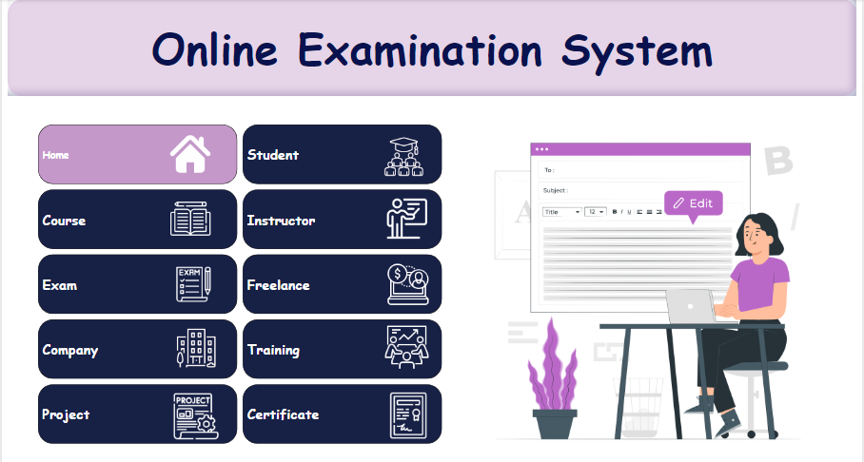

1. **About Student:**

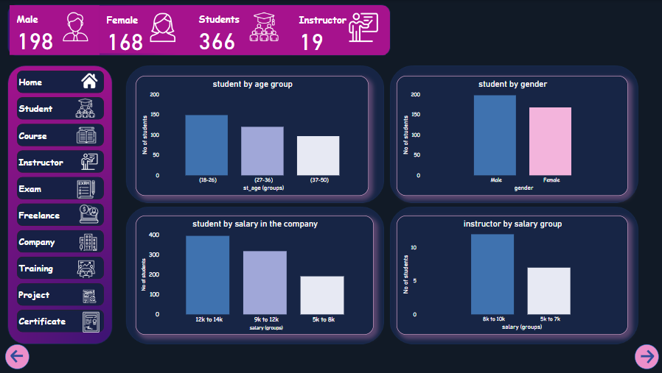

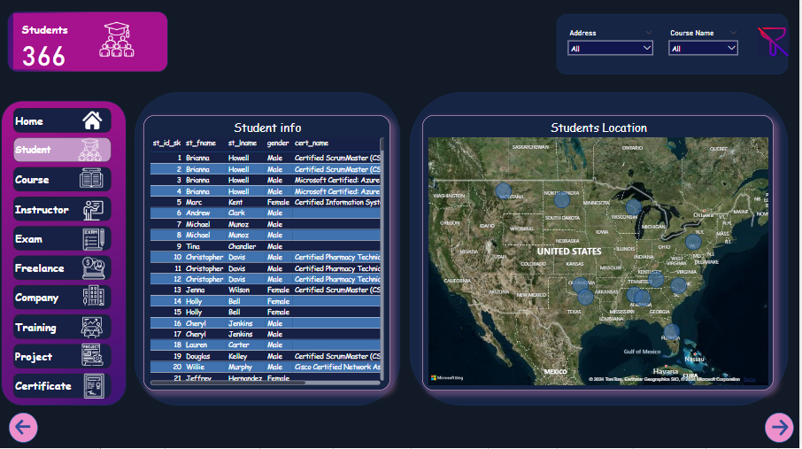

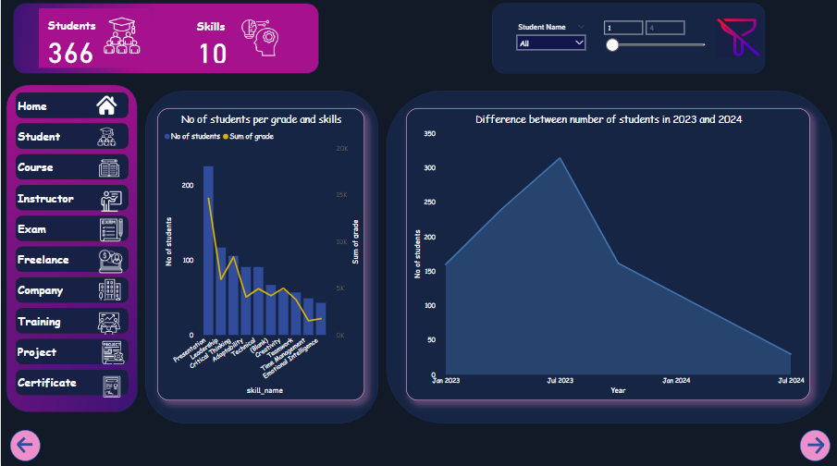

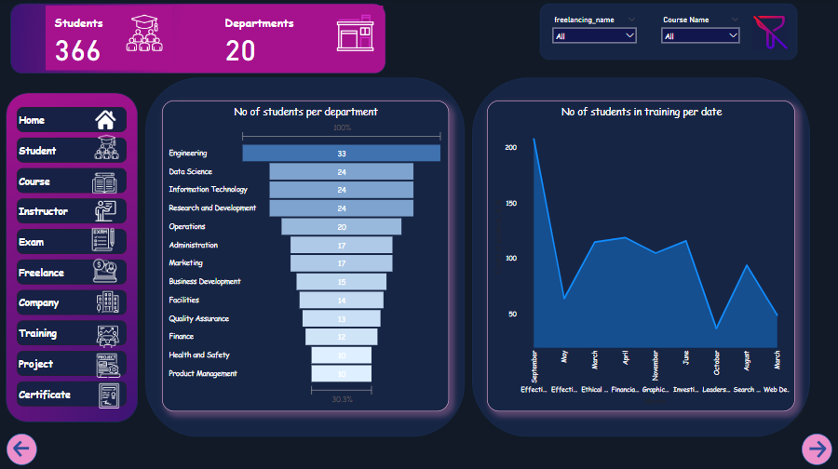

1. **About Courses:**

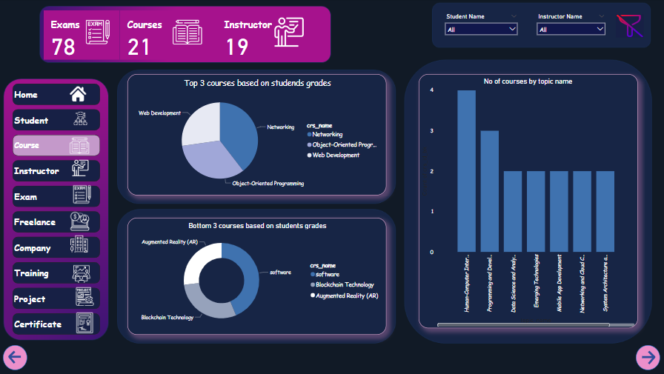

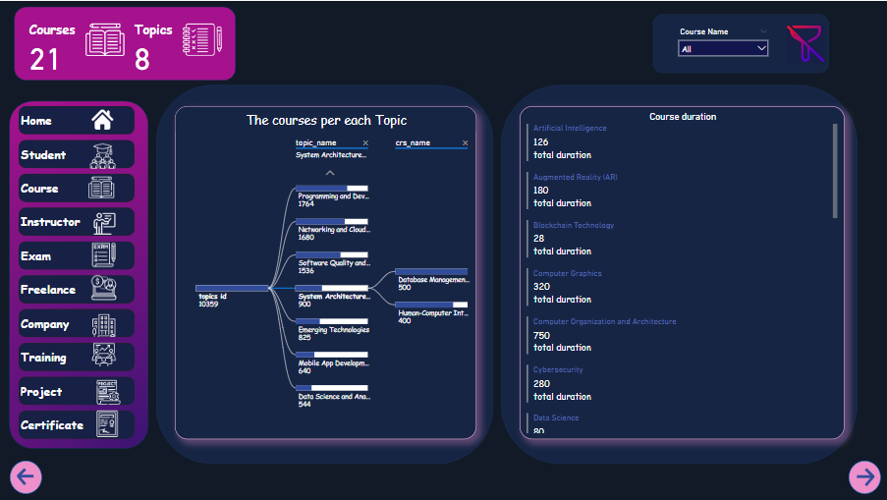

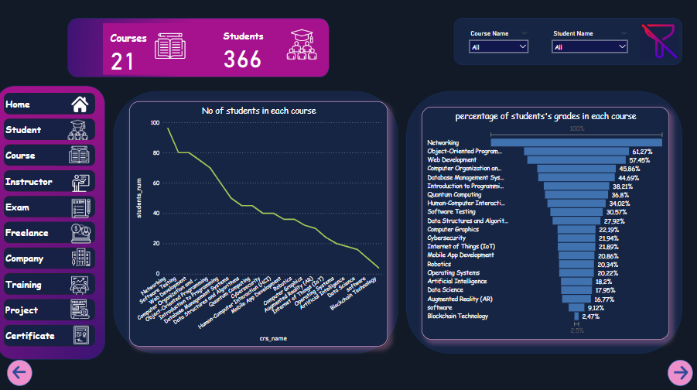

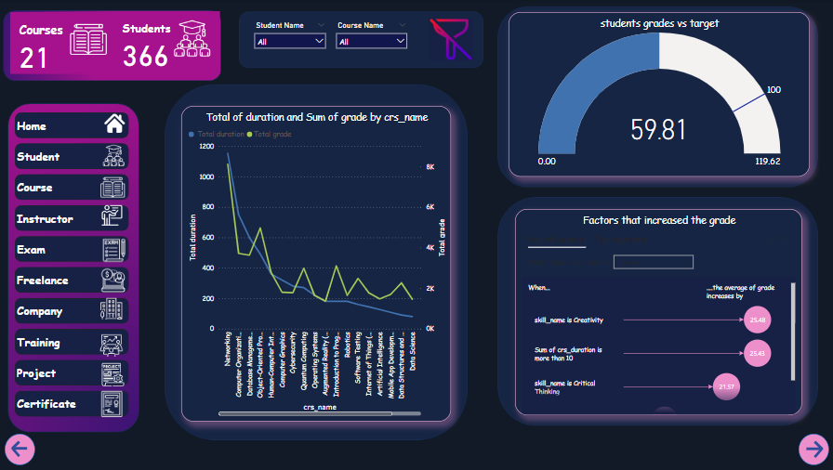

1. **About Instructors:**

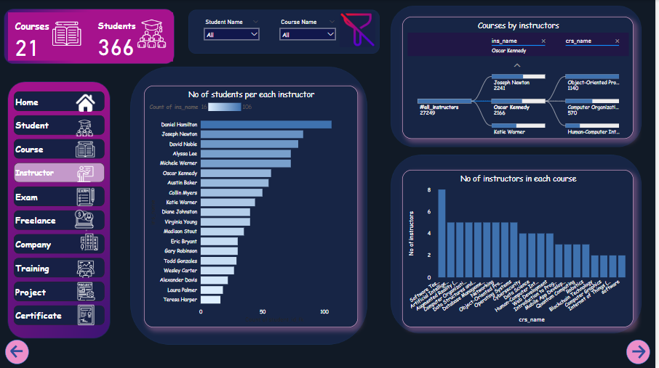

1. **About Exams:**

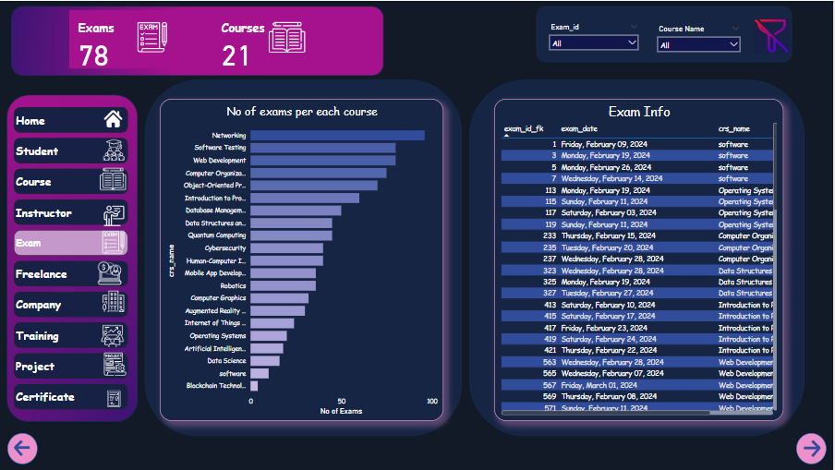

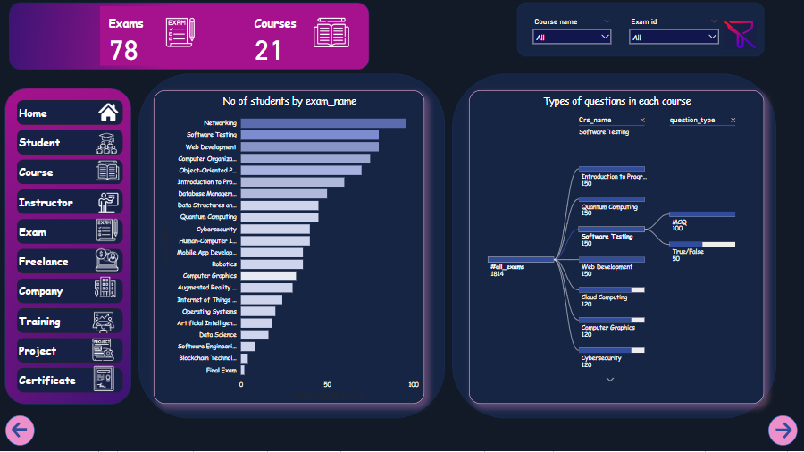

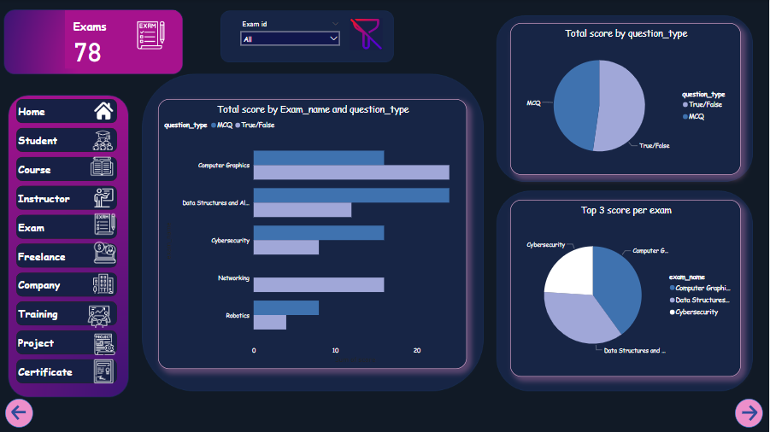

1. **About Freelancing:**

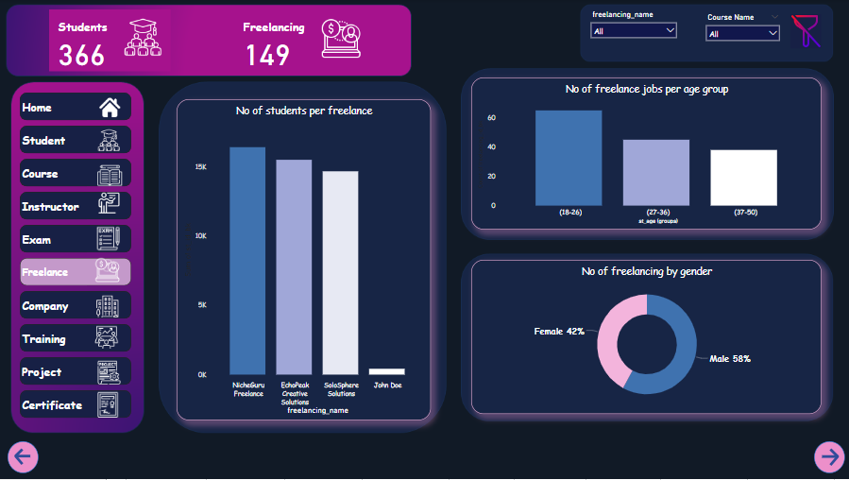

1. **About Companies:**

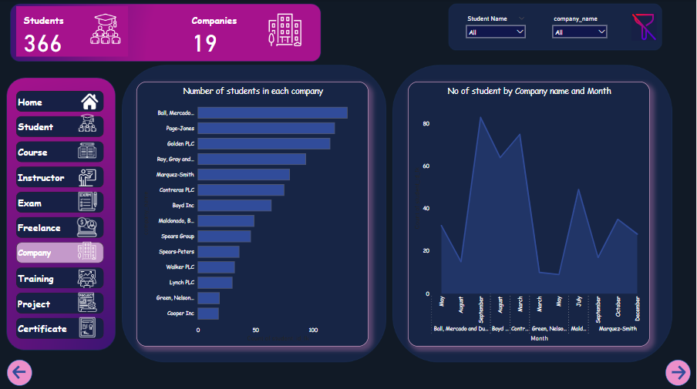

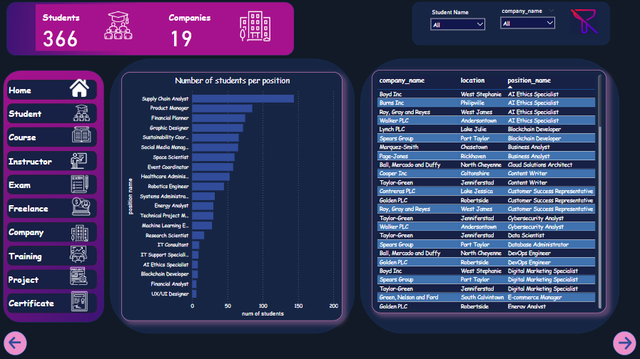

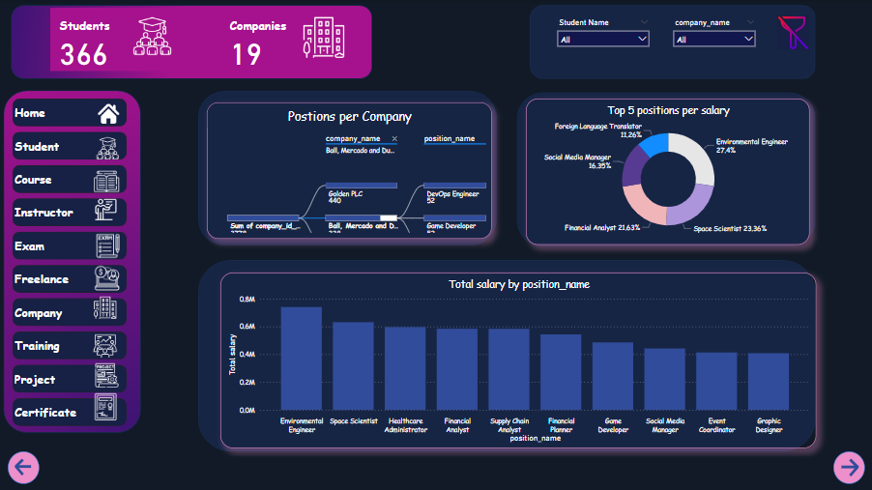

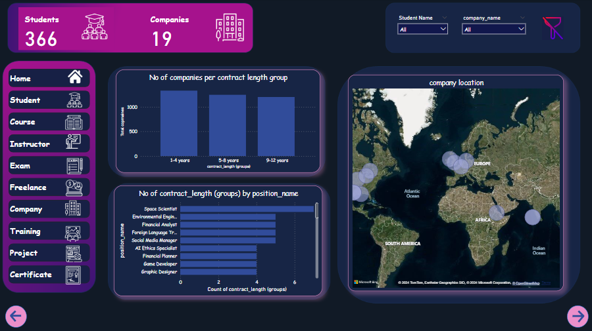

1. **About Training:**

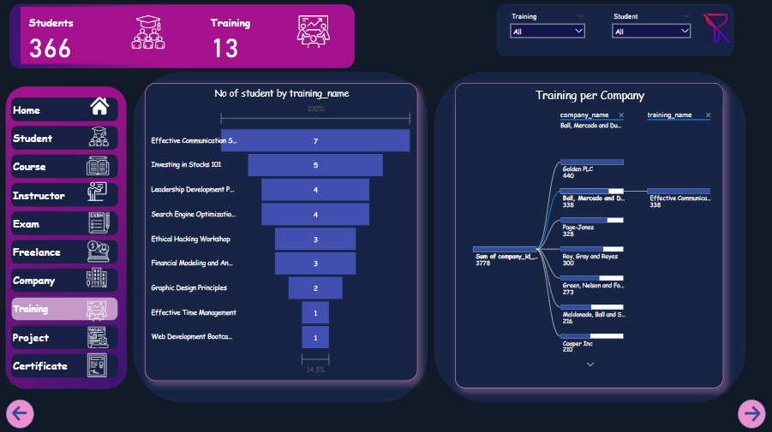

1. **About Projects:**

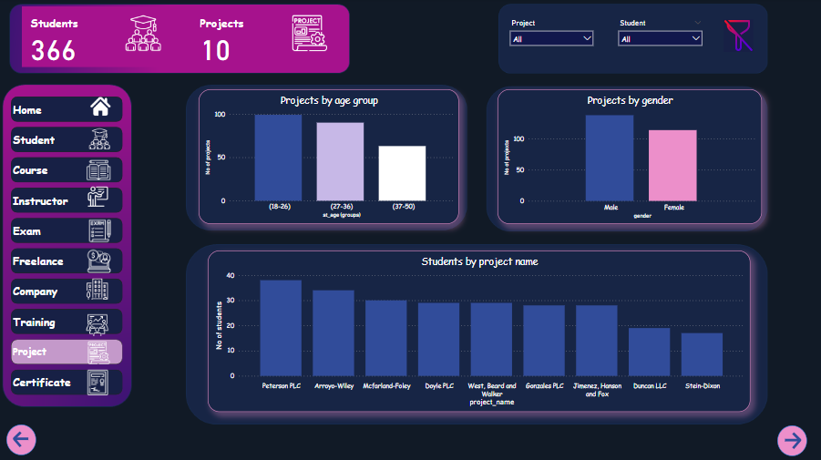

1. **About Certificates:**

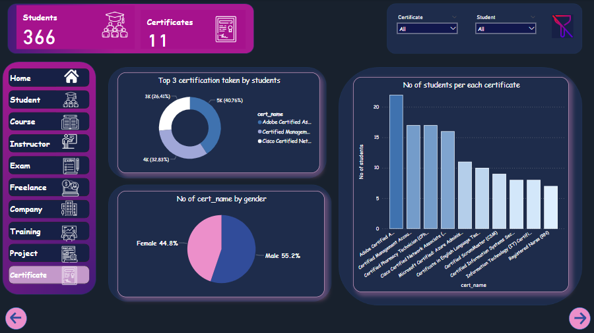

**Web Application:**

1. **Stored procedure for Exam generation:**

create PROCEDURE GenerateBubbleSheet

@ExamId INT

AS

BEGIN

SET NOCOUNT ON;

-- Declare variables

DECLARE @ExamName VARCHAR(100);

-- Get exam name

SELECT @ExamName = Exam_Name

FROM Exam

WHERE Exam_Id = @ExamId;

-- Print exam name

PRINT 'Exam: ' + @ExamName;

-- Declare a temporary table to store the results

CREATE TABLE #BubbleSheet (

QuestionText VARCHAR(200),

OptionText VARCHAR(MAX)

);

-- Insert questions and options into the temporary table

INSERT INTO #BubbleSheet (QuestionText, OptionText)

SELECT EQ.Question_Text, QO.Option_Text

FROM Exam_questions EQ

INNER JOIN Ques_Exam QE ON EQ.Question_Id = QE.Q_Id

INNER JOIN Question_options QO ON EQ.Question_Id = QO.Question_Id

WHERE QE.Ex_Id = @ExamId;

-- Select the results from the temporary table

SELECT * FROM #BubbleSheet;

-- Drop the temporary table

DROP TABLE #BubbleSheet;

END

1. **Stored procedure for Exam Answers:**

CREATE PROCEDURE InsertExamAnswer

@Answer_Text VARCHAR(300),

@Question_Id INT,

@St_Id INT

AS

BEGIN

DECLARE @Score INT;

-- Check if the provided answer matches a correct option for the given question

SELECT @Score = CASE WHEN EXISTS (

SELECT 1

FROM Question_options

WHERE Question_Id = @Question_Id

AND Option_Text = @Answer_Text

AND IsCorrect = 1

)

THEN 1

ELSE 0

END;

INSERT INTO Exam_answers (Answer_Text, Question_Id, Score, St_Id)

VALUES (@Answer_Text, @Question_Id, @Score, @St_Id);

END;

DECLARE @Answer_Text VARCHAR(300) = 'False';

DECLARE @Question_Id INT = 140; -- Provide the appropriate Question_Id

DECLARE @St_Id INT = 108; -- Provide the Student_Id

1. **Stored procedure for Exam corrections:**

create PROCEDURE CompareAnswers

@Question_Id INT,

@Selected_Answer VARCHAR(MAX)

AS

BEGIN

DECLARE @Score INT = 0;

-- Check if the selected answer is correct for the given question

SELECT

CASE WHEN EXISTS (

SELECT 1

FROM Question_options

WHERE Question_Id = @Question_Id

AND Option_Text = @Selected_Answer

AND IsCorrect = 1

)

THEN 1

ELSE 0

END AS Score;

END;

